OT6 United Kingdom II: 1 Kings 1-11, Proverbs, Ecclesiastes, Song of Solomon

Dr. Marvin J. Effa
Author: A number of authors have been suggested as the compiler: Jeremiah, Ezra, or Ezekiel.
Date of writing: Since the author is unconfirmed, the date is as well.
Purpose: To trace the history of the kings of Judah and Israel from the end of David’s life to the Babylonian captivity. 1 and 2 Kings were originally a single book, but the books were divided to make them easier to use.
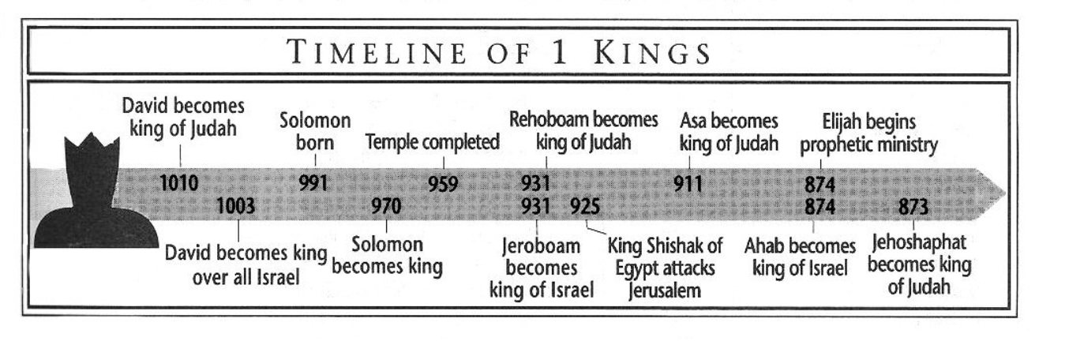
Idea: Following the Lord leads to blessing and security; disobedience brings collapse and captivity.
Development:
- David’s final actions and death, 1 Kings 1:1-2:11.
- Solomon’s consolidation of the nation, 1 Kings 2:12-4:34.
- Solomon’s construction of the temple, 1 Kings 5:1-8:66.
- Solomon’s celebrity status, 1 Kings 9:1-10:29.
- Solomon’s conclusion, 1 Kings 11:1-43.
Key Passage Exegesis
- Examples of Solomon’s wisdom: 1 Kings 2:5, 7, 8, 20, 26, 32, 36, 46; 3:12, 16-28.
- Solomon’s conditional covenant, 1 Kings 9:1-9.
- Queen of Sheba’s visit, 1 Kings 10:1-5.
- Solomon’s downfall, 1 Kings 11:1-8.

Proverbs
Author: Primarily Solomon, but his material was collected and edited by others. The identity of Agur and Lemuel is uncertain (chapters 30 and 31).
Date of writing: 970-931 B.C.
Purpose: To provide a young man with skills needed to live a productive life. The seven-fold purpose statement for the book is found at Proverbs 1:2-7.
Idea: Wisdom is a skill given by the Lord that enables the possessor to negotiate every event in life.
Development: A proverb is fundamentally a literary tool that teaches by transference. The reader must think about each proverb until the author’s intent is understood. The intent is rarely to provide an absolute truth for every situation, but to show concepts that help in life’s management.
- An introduction to the book intended to create an appetite for wisdom, Proverbs 1:1-9:18.
- The actual proverbs for which the book is named, Proverbs 10:1-31:31.
Key Passage Exegesis:
- The seven-fold purpose statement for the book is found at Proverbs 1:2-7.
- The dangers of immorality, Proverbs 7.
- The wise woman, Proverbs 31.

Ecclesiastes
Author: Although not stated, only Solomon meets the descriptions provided.
Date of writing: 935 B.C., near the end of his reign.
Purpose: To prove that life is meaningless if God is left out.
Idea: A fulfilled life comes by seeking the Lord and following Solomon’s commands.
Development: Ecclesiastes does not lend itself to a tight, logical development. Rather, the author provides information and summaries that lead the reader to a conclusion. In some sense, the end of the book is the beginning. His opening statement, Ecclesiastes 1:2, is still his concluding statement, Ecclesiastes 12:8. Solomon argues that life is meaningless and no one is able to prove him wrong. He examines a life without God, but as God is brought into life, life becomes significant. A life lived with God becomes meaningful; God intends for people to enjoy life and keep his commandments.
- Cycle one: Ecclesiastes 1:1-2:26 (summary statement in Ecclesiastes 2:24-26).
- Cycle two: Ecclesiastes 3:1-11 (summary statement in Ecclesiastes 3:12-13).
- Cycle three: Ecclesiastes 3:14-21 (summary statement in Ecclesiastes 3:22).
- Cycle four: Ecclesiastes 4:1-5:20 (summary statement in Ecclesiastes 5:18-20.
- Cycle five: Ecclesiastes 6:1-8:15 (summary statement in Ecclesiastes 8:15).
- Cycle six: Ecclesiastes 8:16-12:12 (summary statement in Ecclesiastes 12:9-12).
- Cycle seven: Ecclesiastes 12:13-14, the conclusion of everything.
Having argued that God wants us to enjoy life, Solomon provides imperatives as to how one actually does that.
- Begin with worship, Ecclesiastes 5:1-7.
- Be optimistic, Ecclesiastes 7:9-10.
- Be submissive, Ecclesiastes 7:14.
- Be humble, Ecclesiastes 7:16-22.
- Be obedient, Ecclesiastes 8:2-3.
- Love your wife joyfully, Ecclesiastes 9:7-9.
- Work hard, Ecclesiastes 9:10.
- Be faithful, Ecclesiastes 10:4.
- Respect authority, Ecclesiastes 10:20.
- Be generous, Ecclesiastes 11:1-6.
- Survive youth, Ecclesiastes 11:9-12:1.
- Fear God and keep His commandments, Ecclesiastes 12:13.
Key Passage Exegesis:
- Prosecution of evil doers, Ecclesiastes 8:11.
Song of Solomon
Author: Solomon, although most of the words are from Shulamite.
Date of writing: 970-965 B.C., possibly near the beginning of his reign.
Purpose: To provide the Israelites with a romance play.
Idea: Spousal love is so intense that people should wait until maturity to marry.
Development: The play is made up of various scenes leading up to the wedding, followed by typical problems which couples must resolve.
- First meetings until the wedding night, Songs 1:1-3:11.
  - Shulamite in the harem, Songs 1:1-4.
  - The king at work, Songs 1:5-11.
  - A forest walk, Songs 1:12-15.
  - A picnic, Songs 1:16-2:7.
  - Relationship’s interruptions, Songs 2:8-17.
  - A very bad dream, Songs 3:1-5.
  - Everyone loves a wedding, Songs 3:6-11.
- The honeymoon, Songs 4:1-5:1.
- The problem of sexual adjustment, Songs 5:2-7:10.
  - “I have a headache,” Songs 5:2-8.
  - How to make up, Songs 5:9-6:13.
  - Making up for lost opportunities, Songs 7:1-10.
- How to get along with the in-laws, Songs 7:11-8:14.
Key Passage Exegesis:
- The reoccurring theme: Songs 2:7, 3:5, 8:4.

